Decision Template - Should I Hire?
This template has been developed to help business owners determine whether or not they are, in fact, in a position to hire. This activity will take the user through both what the individual could do and most importantly, is it within budget?
This activity should be completed over a couple of days to maximise the value of the input.

Revenue & Income
- The first part of the activity is to allocate your estimated revenue each month across the financial year
- Plot your personal estimated monthly income for each month
- Calculate the difference between your estimated revenue and your personal estimated income
- Calculate the estimated hours that you work per month
- Complete this row at the end of the exercise when you know roughly what you may need to pay for the support you require

Financial Year 20XX / 20XX
 | Revenue | Jul | Aug | Sep | Oct | Nov | Dec | Jan | Feb | Mar | Apr | May | Jun
1 | E.g $xK
2 | Income paid to you
3 | Difference
4 | Hours worked per month
5 | Expected rate of pay for new hire

What do I need?
The next stage is to start a mind map of everything that you do in a week - and I mean everything!
These activities will vary from business owner to business owner and are likely to cover a wide range of tasks.
Example
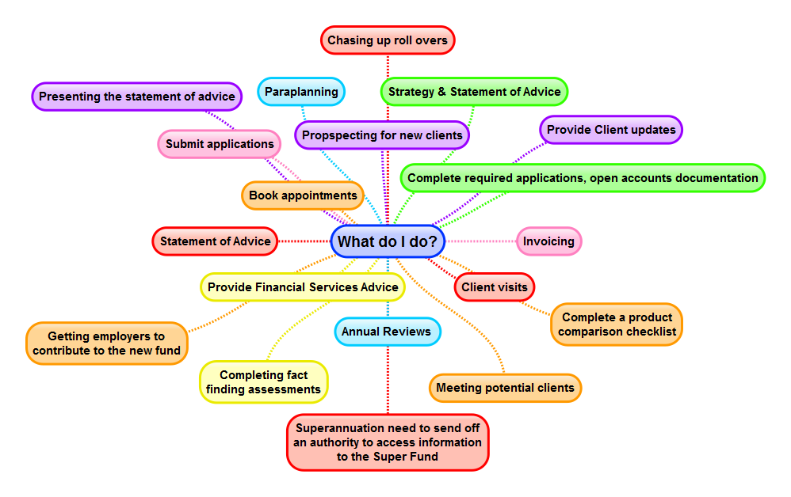

Complete your mind map below:

Review
- Now put your workings / mind map away for 24-48 hrs and then come back to it. Are there any tasks that you have forgotten? You may have forgotten reporting or financials, for example.
- Allocate a timespan to everything that you do. For example, answering the phone - how much time would this take up in an average day and then in an average week? Is it 2hrs per day or per week or is most of your client contact through email?
- Now place a red circle around each of the activities that you feel are your strengths - the pieces that you are an expert in. This is different to the pieces that you can do. As business owners, we can do most things but this does not mean that it is the best use of our time.
- Now review what is left uncircled and add up the hours that it would save you each week, if this work was to be completed by someone else. Think about what these hours would mean to your business development, account management or face-to-face client time.
- The next step is to determine what it would cost you to get someone else to do this work. As an example, to get an admin person to complete some of the tasks, it would probably cost you about $20.13 per hour as a permanent part time employee and $25.16 per hr as a casual employee, inclusive of casual loading (Clerks-Private Sector Award 2010). You will also need to consider the on-costs of superannuation and workers compensation associated with employees.
- The last step is to complete row 6 with an indicative hourly rate to pay your new employee.
- Now if the results prove that you can recover the costs of your employee but the additional time and revenue you can produce then it is time to consider hiring your first employee.

